Table of Contents
Task 3, part 1 2
4.8 Foreign keys and integrity rules 2
Foreign keys in the schema 2
Primary keys 2
Foreign keys 2
Entity integrity 2
Referential integrity 3
4.9 Sample tables that observe relational integrity rules 3
Hotel table 3
Room table 3
Guest table 4
Booking table 4
General constraints appropriate for this schema 4
Task 3, Part 2 — Exercise 12.10 5
a. Company and Department 5
b. Department and Employee 5
c. Employee and Dependent 5
d. Employee and Employment History 6
e. Single ER Model 6
Relationship summary 7

Task 3, part 1

4.8 Foreign keys and integrity rules

Foreign keys in the schema
The relations are:
Hotel(hotelNo, hotelName, city)
Room(roomNo, hotelNo, type, price)
Booking(hotelNo, guestNo, dateFrom, dateTo, roomNo)
Guest(guestNo, guestName, guestAddress)

Primary keys
Relation | Primary Key
Hotel | hotelNo
Room | roomNo,hotelNo
Booking | hotelNo,guestNo,dateFrom
Guest | guestNo

Foreign keys
Relation | Foreign Key | References
Room | hotelNo | Hotel(hotelNo)
Booking | hotelNo | Hotel(hotelNo)
Booking | guestNo | Guest(guestNo)
Booking | roomNo, hotelNo | Room(roomNo, hotelNo)

Because Room has a composite primary key of (roomNo, hotelNo), the booking should reference both roomNo and hotelNo to identify exactly which room in which hotel was booked.

Entity integrity
Entity integrity means that every relation must have a primary key, and the primary key values cannot be null.
In this schema:
Hotel.hotelNo must not be null.
Room.roomNo and Room.hotelNo must not be null.
Booking.hotelNo, Booking.guestNo, and Booking.dateFrom must not be null.
Guest.guestNo must not be null.
This ensures that every hotel, room, booking, and guest can be uniquely identified.

Referential integrity
Referential integrity means that a foreign key value must either match an existing primary key value in the referenced table, or be null if the relationship is optional.
In this schema:
A room cannot exist for a hotel that is not in the Hotel table.
A booking cannot be made for a hotel that does not exist.
A booking cannot be made by a guest who does not exist.
A booking cannot be made for a room that does not exist in the Room table.
This prevents invalid records, such as booking room 101 in hotel H99 if hotel H99 does not exist.

4.9 Sample tables that observe relational integrity rules

Hotel table
hotelNo | hotelName | city
H001 | Grand Palace Hotel | London
H002 | Riverside Hotel | Manchester
H003 | City View Hotel | Birmingham

Room table
roomNo | hotelNo | type | price
101 | H001 | Single | 80.00
102 | H001 | Double | 120.00
201 | H002 | Single | 70.00
202 | H002 | Double | 110.00
301 | H003 | Suite | 180.00

All hotelNo values in this table already exist in the Hotel table, so referential integrity is maintained.

Guest table
guestNo | guestName | guestAddress
G001 | Sandeep Hamal | Hounslow
G002 | Subham Chaudhary | Whoolwich
G003 | Prakash Sapp | London

Booking table
hotelNo | guestNo | dateFrom | dateTo | roomNo
H001 | G001 | 2026-06-01 | 2026-06-05 | 101
H001 | G002 | 2026-06-10 | 2026-06-12 | 102
H002 | G003 | 2026-07-01 | 2026-07-03 | 201
H003 | G001 | 2026-08-15 | 2026-08-18 | 301

All bookings are valid because:
Each hotelNo exists in Hotel.
Each guestNo exists in Guest.
Each (roomNo, hotelNo) combination exists in Room.

General constraints appropriate for this schema
Suitable constraints could include:
Constraint | Explanation
hotelNo must be unique and not null | Each hotel must be uniquely identified
guestNo must be unique and not null | Each guest must be uniquely identified
(roomNo, hotelNo) must be unique and not null | Room numbers may repeat across hotels, but not within the same hotel
(hotelNo, guestNo, dateFrom) must be unique and not null | Prevents duplicate booking records
price > 0 | Room price should be a positive value
dateTo > dateFrom | A booking must end after it starts
type should be limited to valid values | For example: Single, Double, Family, Suite
A room cannot be double-booked for overlapping dates | The same room in the same hotel should not be booked by two guests at the same time
Foreign keys must match existing records | Prevents bookings for non-existing hotels, rooms, or guests

Task 3, Part 2 — Exercise 12.10

a. Company and Department
Each company operates four departments, and each department belongs to one company.
COMPANY 1 - 4 DEPARTMENT
Relationship: Company operates Department
Cardinality:
One company operates four departments
Each department belongs to one company

b. Department and Employee
Each department employs one or more employees, and each employee works for one department.
DEPARTMENT 1 - M EMPLOYEE
Relationship: Department employs Employee
Cardinality:
One department employs one or more employees
Each employee works for one department

c. Employee and Dependent
Each employee may or may not have one or more dependents, and each dependent belongs to one employee.
EMPLOYEE 1 - M DEPENDENT
Relationship: Employee has Dependent
Cardinality:
One employee may have zero, one, or many dependents
Each dependent belongs to one employee

This means the relationship is optional on the employee side because an employee may have no dependents.

d. Employee and Employment History
Each employee may or may not have an employment history.
EMPLOYEE 1 - M EMPLOYMENT_HISTORY
Relationship: Employee has Employment History
Cardinality:
One employee may have zero, one, or many employment history records
Each employment history record belongs to one employee
This is also optional because an employee may not have any employment history.

e. Single ER Model
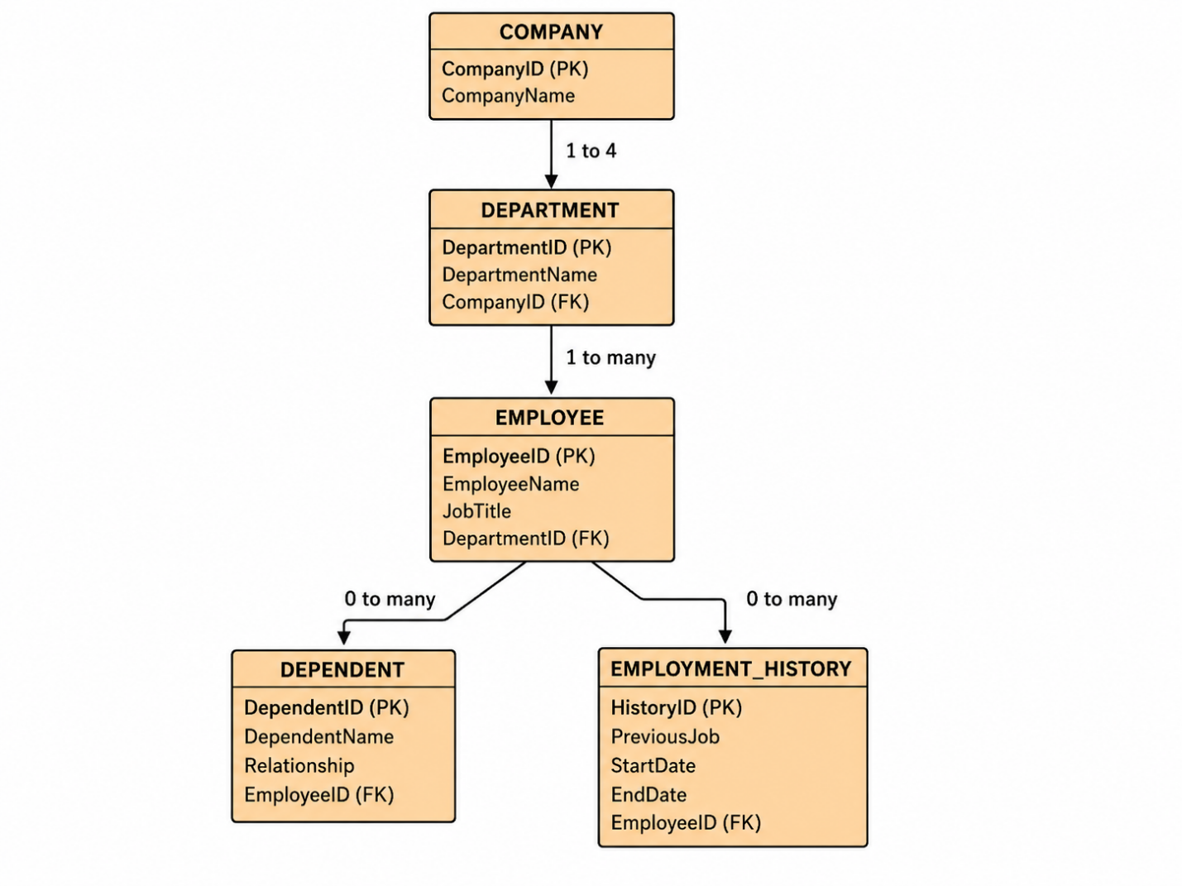

Relationship summary
Relationship | Cardinality
Company operates Department | One company to four departments
Department employs Employee | One-to-many
Employee has Dependent | One-to-many, optional
Employee has Employment History | One-to-many, optional

